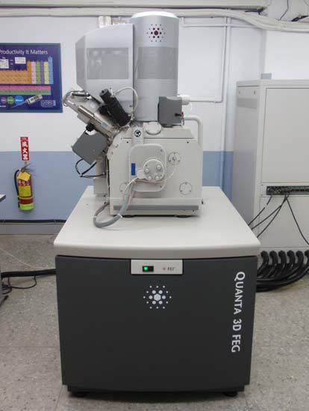
Equipment: | Dual Beam Focused Ion Beam(FIB)
Brand and Type: | FEI Quanta 3D FEG
Place: | E1‐145
Professor in responsibility | 朱瑾
Engineer in responsibility | 廖勝權
Purchased since | 2010.12
Intramural | - Ion cutting and observation.  $3000/hr (currently 50% off)  - TEM specimen preparation  $3000/per specimen  - SEM function only  $800/hr  - Platinum electrode expenses is not included. The price of using platinum electrode is $200 / 5 min. For the usage less than 5 minutes, it still counts as 5 min.  - Pay 10 hours in advance, gets one extra hour.
Extramural (Academic) | - Ion cutting and observation.  $5000/hr (currently 50% off)  - TEM specimen preparation  $5000/per specimen  - SEM function only  $1600/hr  - Platinum electrode expenses is not included. The price of using platinum electrode is $200 / 5 min. For the usage less than 5 minutes, it still counts as 5 min.  - Pay 10 hours in advance, gets one extra hour.
Extramural (Industry) | - Ion cutting and observation.  $7000/hr (currently 50% off)  - TEM specimen preparation  $7000/per specimen  - SEM function only  $2000/hr  - Platinum electrode expenses is not included. The price of using platinum electrode is $200 / 5 min. For the usage less than 5 minutes, it still counts as 5 min.  - Pay 10 hours in advance, gets one extra hour.

Service hours | Time | Monday | Tuesday | Wednesday | Thursday | Friday
 | Morning  9:00~11:00 | Extramural  (1st priority) | Extramural  (1st priority) | Extramural  (1st priority) | Extramural  (1st priority) | Instrument maintenance
 | Noon  11:00~14:00 | Intramural  (1st priority) | Intramural  (1st priority) | Intramural  (1st priority) | Intramural  (1st priority) | Intramural  (1st priority)
 | Afternoon  14:00~16:00 | Extramural  (1st priority) | Extramural  (1st priority) | Extramural  (1st priority) | Extramural  (1st priority) | Extramural  (1st priority)

